|  |  |  |  |  |
| --- | --- | --- | --- | --- |
| **National University of Computer and Emerging Sciences, Lahore Campus** | | | | |
| C:\Users\saif\AppData\Local\Microsoft\Windows\Temporary Internet Files\Content.Word\final design.jpg | **Course:** | **Design & Analysis of Algorithms** | **Course Code:** | **CS2009** |
| **Program:** | **BS (Computer Science)** | **Semester:** | **Spring 2023** |
| **Duration:** | **15 Minutes** | **Total Marks:** | **10** |
| **Paper Date:** | **30-March-2023** | **Weight:** | **4** |
| **Section:** | **J** | **Page(s):** | **1** |
| **Exam:** | **Quiz 4** | **Reg. No.** |  |
| **Instruction/Notes:** |  | | | |

**Question 1: CLO 1, [10 marks]**

Topological Sorting

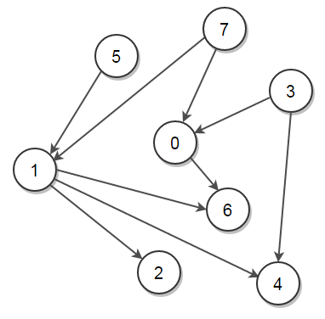

Solution:

